
Western International College FZE
BTEC RQF Higher Nationals In Electrical & Electronics Engineering
Unit 4019 – Electrical and Electronic Principles
Semester 1 2025 - 26

In Class Test: Fundamental Circuit Analysis
Date: 12 November 2025
Duration: 6 hours

Instructions To Students:

- There are 8 questions on this question paper.
- Answer all questions.
- This is an open book test where you are allowed to bring only your class notes.
- You are strongly advised to plan your answers
- Silent engineering/scientific calculators may be used provided that data and program storage memory is cleared prior to the examination
- Start each answer in a fresh answer sheet
- Your answers should: clearly present steps to each question and also give critical evaluation, and justify your answer to relevant circuit theory

Outcome | Assessment criteria | Tasks to Achieve | Achived?  Y/N
Apply an understanding of fundamental electrical quantities to analyse circuits with constant voltages and currents | P1 Apply the principles of circuit theory to simple circuits with constant sources, to explain the operation of that circuit. | Q1, Q2, Q3, Q4, Q5, Q6, Q7, Q8
 | M1 Apply the principles of circuit theory to a range of circuits with constant sources, to explain the operation of that circuit. | Q1, Q2, Q3, Q4, Q5, Q6, Q7, Q8
 | D1 Examine the operation of a range of circuits with constant sources, including power analysis, using relevant circuit theories. | Q1, Q2, Q3, Q4, Q5, Q6, Q7, Q8

Student Name
Student Number

Q1.

For the arrangement shown in Figure 1, find the current Ix. Use Ohm’s Law and basic circuit analysis techniques to determine the current flowing through the resistor.

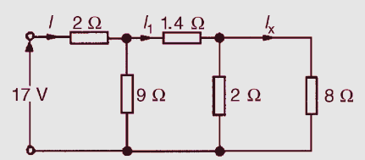

Figure. 1

Q2.

For the series-parallel arrangement shown in Figure.2, apply Ohm’s Law, voltage division, and current division, find:

(a) The supply current,

(b) The current flowing through each resistor

(c) The potential difference (p.d.) across each resistor.

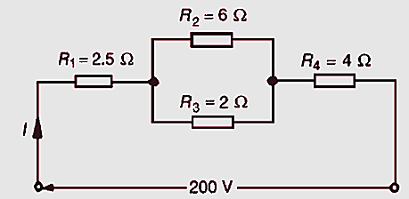

Figure. 2

Q3.

Apply Kirchhoff’s Current Law (KCL) and Kirchhoff’s Voltage Law (KVL) to find the current in each branch of the circuit given in Figure 3.

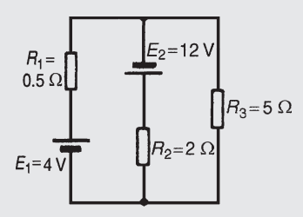

Figure. 3

Q4.

Apply KCL to analyse the operation of the bridge circuit to determine the current flowing through each resistor.

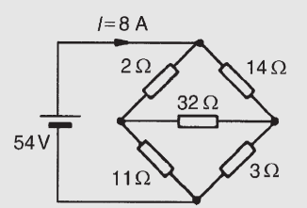

Figure. 4

Q5.

For the circuit shown in Figure 5 containing two e.m.f. sources with internal resistances, use the superposition theorem to determine the current in each branch.

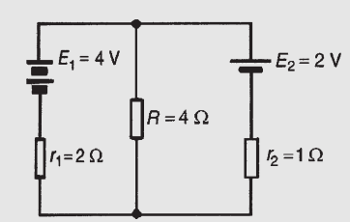

Figure. 5

Q6.

Use Thevenin’s Theorem to determine the current I flowing through the 4 Ω resistor in Figure 6. Calculate the power dissipated in the 4 Ω resistor.

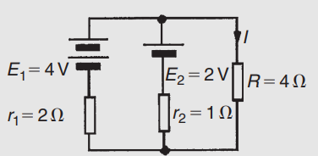

Figure. 6

Q7.

Use Norton’s Theorem to determine the current flowing through the 10 Ω resistor in Figure 7.

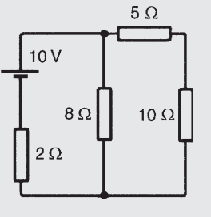

Figure. 7

Q8.

For the circuit shown in Figure 8, calculate the value of the load resistor R_{L} that gives maximum power dissipation and determine the value of the maximum power dissipated by the resistor.

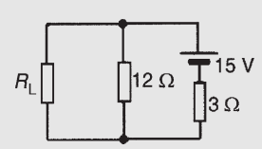

Figure. 8

